Ethics of Algorithms for Resource Allocation – Activity 2

For this activity, you will be assigned the role of one of the following stakeholders (1-8):

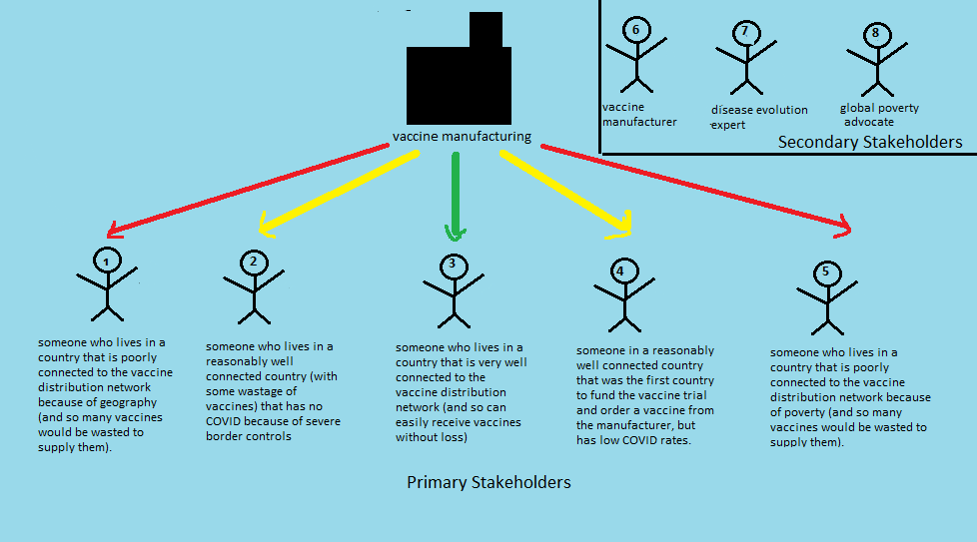

Question 1 [10 minutes]:

If you were assigned one of stakeholders 1-5, please answer the following: “Consider the building blocks of fairness (equality, efficiency, rights to a minimum, desert). What would each of these building blocks say about the relative priority of your country compared to other countries in obtaining a vaccine?”

If you were assigned one of stakeholders 6-8, please answer the following: “What special knowledge do you possess that would be relevant to vaccine distribution?”

Question 2 [10 minutes]:
If you were assigned one of stakeholders 1-5, please answer the following: “Compare your country to the other countries. Who do you think should receive a vaccine sooner than you, out of fairness? Who do you think should have to wait until after your country has received a vaccine?“

If you were assigned one of stakeholders 6-8, please answer the following: “Given your technical knowledge, what advice might you give to each of these people?
- Someone who wants to make sure that as few vaccines as possible are wasted.
- Someone who wants to make sure that the greatest worldwide reduction of COVID is achieved in the short term.
- Someone who wants to make sure that the greatest worldwide reduction of COVID is achieved in the long term.”

